Ùhúnmwèlaò (head of an ọ́bà)
Artists of the Ìgùn Ẹ́rọ̀nwwọ̀n brass-casting guild | Early 15th–mid-16th century | Record IMG-WAF0012

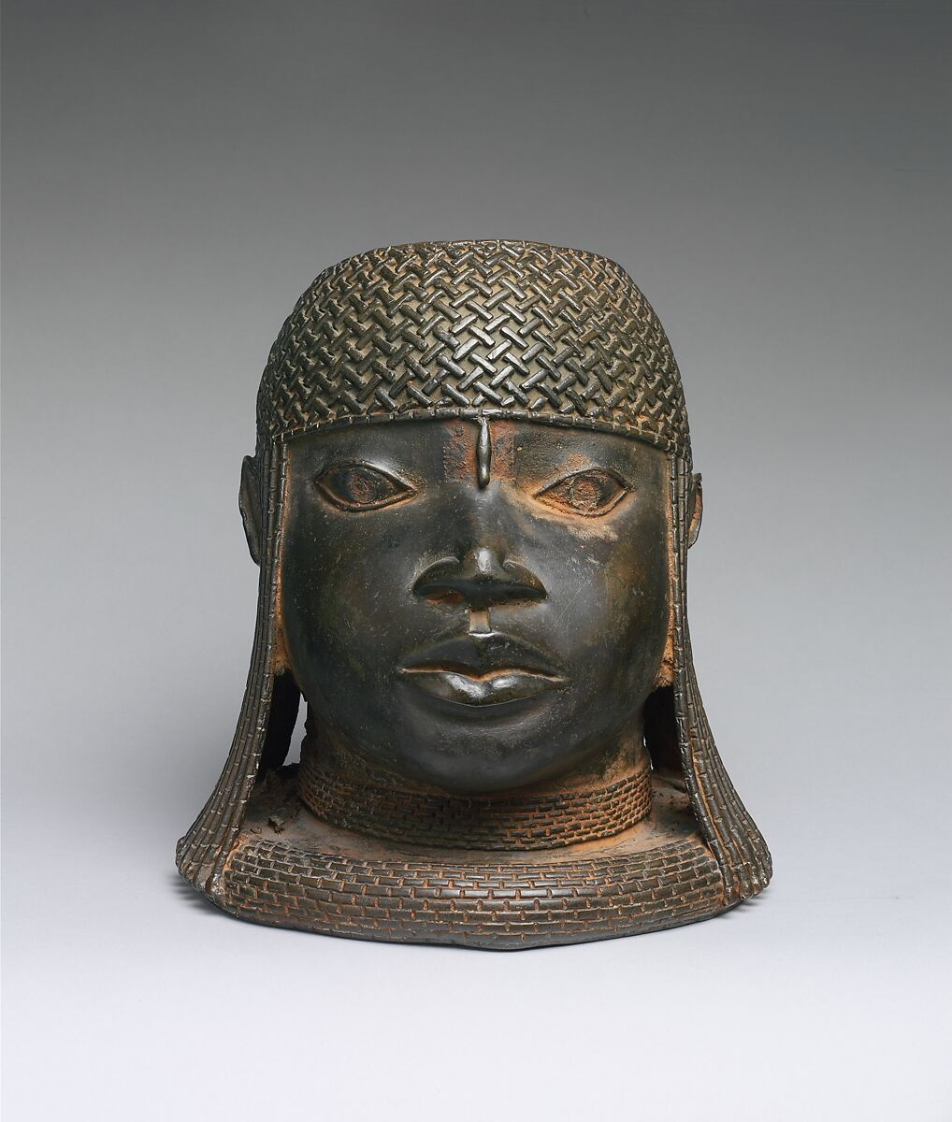
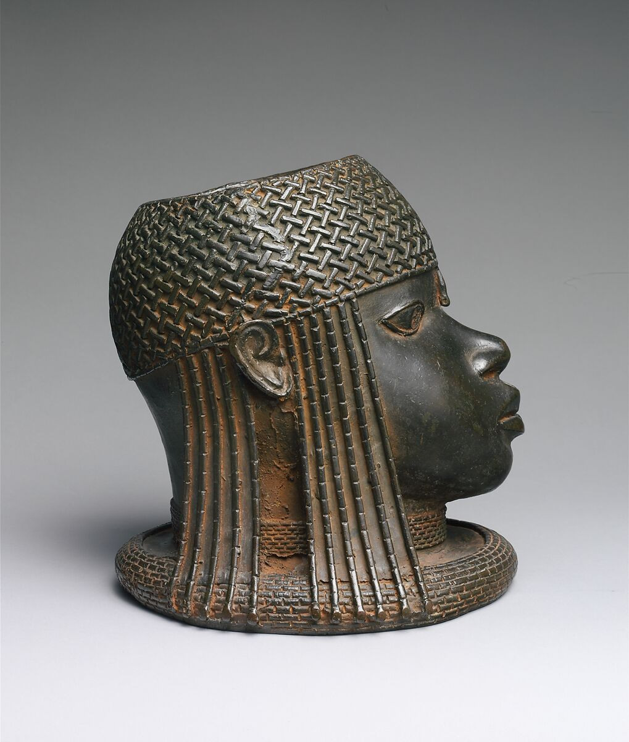
1. Original Image

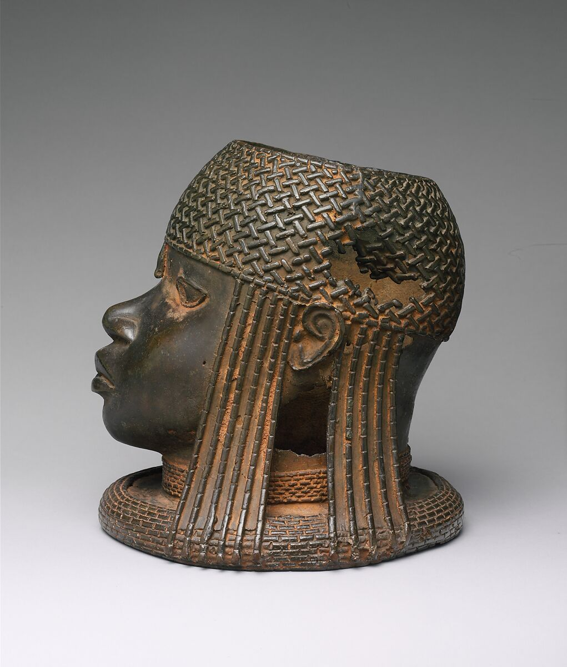
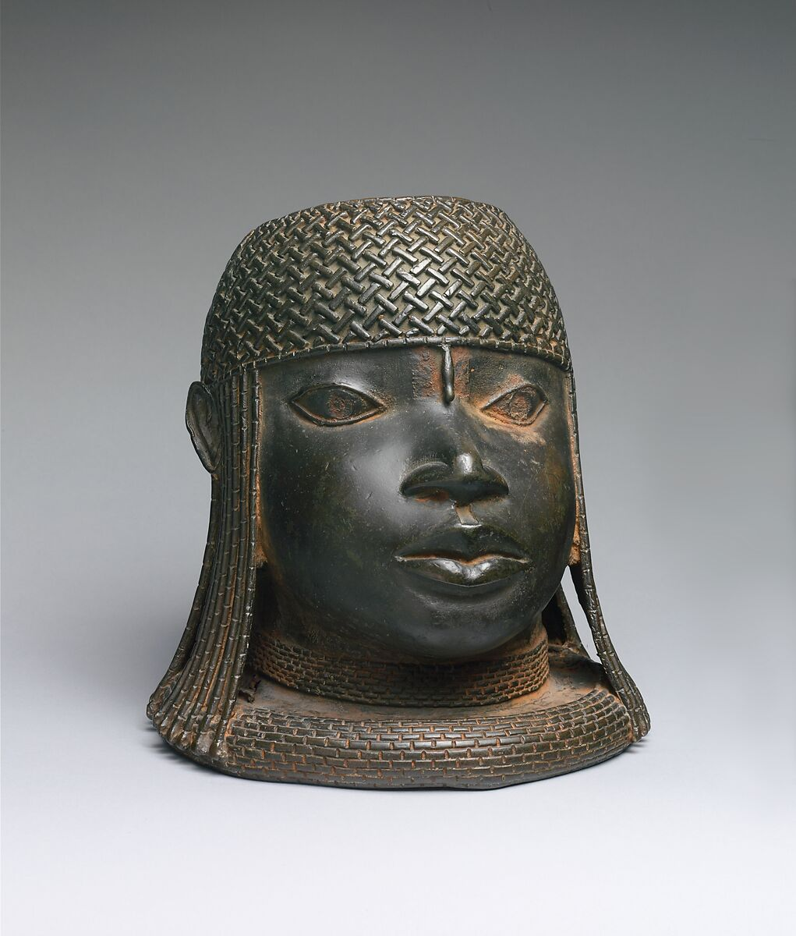

IMG-WAF0012. Ìgùn Ẹ́rọ̀nwwọ̀n (brass-casting guild) artists, Ùhúnmwèlaò (head of an ọ́bà), Early 15th–mid-16th century, Nigeria, Court of Benin, Edo peoples, Brass, iron, H. 9 1/4 x W. 8 5/8 x D. 9 in. (23.5 x 21.9 x 22.9 cm), Metal-Sculpture. The Metropolitan Museum of Art.

2. Record Summary
Record ID | IMG-WAF0012
Original title | Ùhúnmwèlaò (head of an ọ́bà)
English title | Ùhúnmwèlaò (Head of an Oba / King)
Alternative title | Commemorative head of an oba
Creator | Artists of the Ìgùn Ẹ́rọ̀nwwọ̀n brass-casting guild
Creation date | Early 15th–mid-16th century
Country | Nigeria
Cultural region | West Africa; Court of Benin
Historical period | Sculpture shown through an institutional object photograph
Image type | Textile shown through an institutional object photograph
Medium | Brass and iron
Dimensions | 23.5 × 21.9 × 22.9 cm
Primary subject | Cast-brass commemorative royal head
Secondary subjects | Beaded cap, forehead ornament, lateral strands, collar and neutral museum background
Source institution | The Metropolitan Museum of Art
Collection or object number (optional) | 1979.206.86

3. Image Description

3.1 Short Description
A frontal museum photograph shows a cast-metal head with a rounded face, almond-shaped eyes, broad nose and closed lips. A densely patterned cap covers the crown, with long beaded strands descending beside both ears. A layered collar forms a wide base against a neutral grey background.

3.2 Detailed Visual Description
The sculpture consists of a head, neck and broad collar without shoulders. The face is nearly symmetrical. A narrow bead or ornament descends from the cap to the centre of the forehead. The cap is covered with raised interlocking patterns resembling woven or beaded work.
Long strands descend beside the ears and connect visually with the layered collar. The metal surface is dark brown-black with reddish and golden areas of wear or oxidation. Soft studio light produces highlights on the forehead, lips and patterned surfaces. A circular opening is visible at the top of the cap.

4. Formal Features
Field | Analysis
Composition | Centred and nearly symmetrical frontal presentation.
Viewpoint or camera angle | Directly level with the face.
Shot scale | Close object view showing the full sculpture.
Spatial depth | Compact three-dimensional volume.
Lighting | Soft museum studio lighting.
Colour palette | Dark brown-black, reddish bronze, muted gold and grey.
Contrast | Dark sculpture against a pale background.
Visual focus | Eyes, forehead ornament and patterned cap.
Texture | Smooth face contrasted with raised bead-like patterns.
Movement or stillness | Static and frontal.
Medium-specific features | Casting, metallic patina, raised relief, opening and surface wear.

5. Historical Context and Purpose

5.1 Historical Context
The Met attributes the head to artists of the Ìgùn Ẹ́rọ̀nwwọ̀n brass-casting guild and dates it from the early fifteenth to mid-sixteenth century. It represents an idealised oba and originally formed part of a royal commemorative altar in the palace of the Kingdom of Benin. The opening at the crown was intended to support a carved elephant tusk, meaning the head originally functioned within a larger altar ensemble. [IMG-WAF0012-S01] Image Purpose and Circulation

5.2 Image Purpose and Circulation
Verified original purpose: Royal commemoration and ritual use on an ancestral altar.
Current institutional use: Museum display, preservation and art-historical interpretation.

